Below you can find the bugs I found for this link <http://bbcalculator.bugzbusters.com/login>․ Since there are many bugs, I will list them in order.

**Bug report 1**

**Bug ID:** abc001

**Bug Title:** First Name line defects in Personal Information part of Create an account.

**Reported By:** Ani Ghazaryan

**Reported On:** 06 May 2022

**Bug Summary:** There was written that the First name can’t be empty and it should contain 2 - 32 Latin letters, digits, space and symbols (, . ‘- ), but you may do double space or write, for example, only Latin letters and you can move forward**.**

**Bug URL:** [**http://bbcalculator.bugzbusters.com/auth/signup**](http://bbcalculator.bugzbusters.com/auth/signup)

**Environment:** Windows 10, Chrome

**Steps to Reproduce:**  
1) Navigate to [**http://bbcalculator.bugzbusters.com/login**](http://bbcalculator.bugzbusters.com/login)  
2) Click on the “[New? Register now](http://bbcalculator.bugzbusters.com/auth/signup)” button  
3) Write something in “FIRST NAME*” line

**Expected Result:**

You should write a First name that contains 2 - 32 Latin letters, digits, space and symbols (, ' -).

**Actual Result:**   
Defect in step 3 – you could do just double space or write simple Latin letters and move forward.

**Severity:** Medium   
**Priority:** Medium

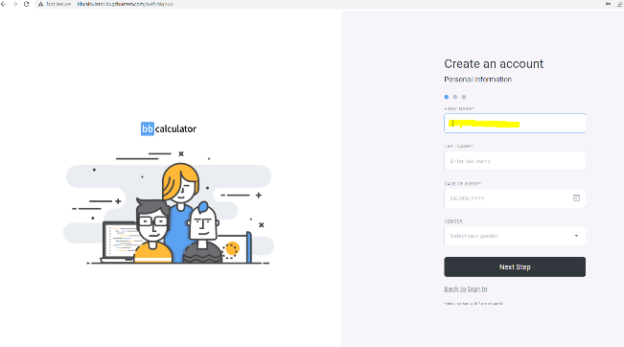**Notes:**  
* See the attached screenshots.

**Bug report 2**

**Bug ID:** abc002

**Bug Title:** Last Name line defects in Personal Information part of Create an account.

**Reported By:** Ani Ghazaryan

**Reported On:** 06 May 2022

**Bug Summary:** There was written that Last name can’t be empty and it should contain 2 - 32 Latin letters, digits, space and symbols (, ' -), but you may do double space or write, for example, only Latin letters and you can move forward**.**

**Bug URL:** [**http://bbcalculator.bugzbusters.com/auth/signup**](http://bbcalculator.bugzbusters.com/auth/signup)

**Environment:** Windows 10, Chrome

**Steps to Reproduce:**  
1) Navigate to [**http://bbcalculator.bugzbusters.com/login**](http://bbcalculator.bugzbusters.com/login)  
2) Click on the “[New? Register now](http://bbcalculator.bugzbusters.com/auth/signup)” button  
3) Write something in “FIRST NAME*” line

4) Write something in “LAST NAME*” line

**Expected Result:**

You should write Last name that contains 2 - 32 Latin letters, digits, space and symbols (, ' -).

**Actual Result:**   
Defect in step 4 – you could do just double space or write just Latin letters and move forward.

**Severity:** Medium   
**Priority:** Medium

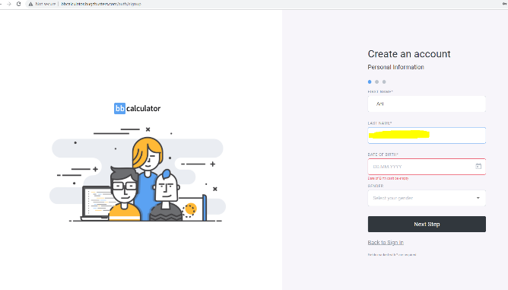**Notes:**  
* See the attached screenshots.

**Bug report 3**

**Bug ID:** abc003

**Bug Title:** Date of birth line defects in Personal Information part of Create an account.

**Reported By:** Ani Ghazaryan

**Reported On:** 06 May 2022

**Bug Summary:** There was written that you should be 12 years old and above, but there is no any upper limit and you may write what you want, besides, if you do not select in the calendar, but simply write a date, if you type for example 10.02.122, it will add 0 before 122 and your date will change to 10.02 .0122․

**Bug URL:** [**http://bbcalculator.bugzbusters.com/auth/signup**](http://bbcalculator.bugzbusters.com/auth/signup)

**Environment:** Windows 10, Chrome

**Steps to Reproduce:**  
1) Navigate to [**http://bbcalculator.bugzbusters.com/login**](http://bbcalculator.bugzbusters.com/login)  
2) Click on the “[New? Register now](http://bbcalculator.bugzbusters.com/auth/signup)” button  
3) Write something in “FIRST NAME*” line

4) Write something in “LAST NAME*” line

5) Write date in “DATE OF BIRTH*” line

**Expected Result:**

You should write valid Date of birth.

**Actual Result:**   
Defect in step 5 – you could write as older age as you want, which cannot exist, but it will be accepted.

**Severity:** Medium   
**Priority:** Medium

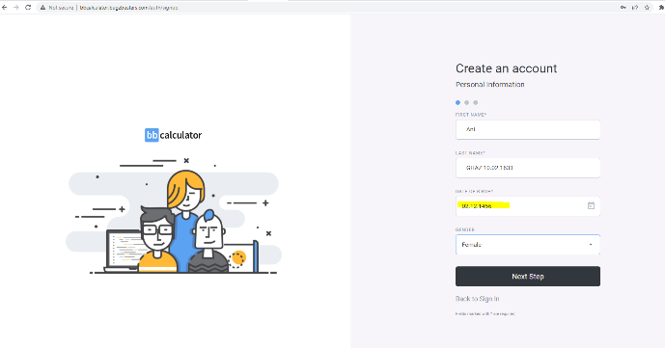**Notes:**  
* See the attached screenshots.

**Bug report 4**

**Bug ID:** abc004

**Bug Title:** Country line defects in Address Information part of Create an account.

**Reported By:** Ani Ghazaryan

**Reported On:** 06 May 2022

**Bug Summary:** There is a list of countries that you can choose from, if you do not select from the list but simply enter an invalid name of a country, it will be accepted and you can move on.

**Bug URL:** [**http://bbcalculator.bugzbusters.com/auth/signup**](http://bbcalculator.bugzbusters.com/auth/signup)

**Environment:** Windows 10, Chrome

**Steps to Reproduce:**  
1) Navigate to [**http://bbcalculator.bugzbusters.com/login**](http://bbcalculator.bugzbusters.com/login)  
2) Click on the “[New? Register now](http://bbcalculator.bugzbusters.com/auth/signup)” button  
3) Write something in “FIRST NAME*” line

4) Write something in “LAST NAME*” line

5) Write date in “DATE OF BIRTH*” line

6) Click on the “Next Step”

7) Write something in “COUNTRY” line

**Expected Result:**

You should write a valid country name.

**Actual Result:**   
Defect in step 7 – you can write whatever you want (space, digit, sign or just one letter) and it will be accepted as a name of a country.

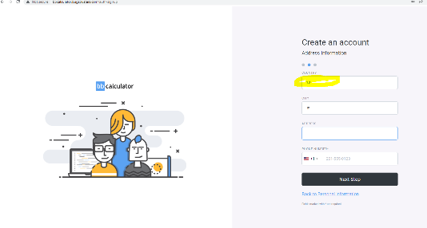**Severity:** Medium   
**Priority:** Medium

**Notes:**  
* See the attached screenshots.

**Bug report 5**

**Bug ID:** abc005

**Bug Title:** City line defects in Address Information part of Create an account.

**Reported By:** Ani Ghazaryan

**Reported On:** 06 May 2022

**Bug Summary:** When you enter an invalid name of a city, it will be accepted and you can move on.

**Bug URL:** [**http://bbcalculator.bugzbusters.com/auth/signup**](http://bbcalculator.bugzbusters.com/auth/signup)

**Environment:** Windows 10, Chrome

**Steps to Reproduce:**  
1) Navigate to [**http://bbcalculator.bugzbusters.com/login**](http://bbcalculator.bugzbusters.com/login)  
2) Click on the “[New? Register now](http://bbcalculator.bugzbusters.com/auth/signup)” button  
3) Write something in “FIRST NAME*” line

4) Write something in “LAST NAME*” line

5) Write date in “DATE OF BIRTH*” line

6) Click on the “Next Step”

7) Write something in “COUNTRY” line

8) Write something in “CITY” line

**Expected Result:**

You should write a valid city name.

**Actual Result:**   
Defect in step 8 – you can write whatever you want (space, digit, sign or just one letter) and it will be accepted as the name of a city.

**Severity:** Medium   
**Priority:** Medium

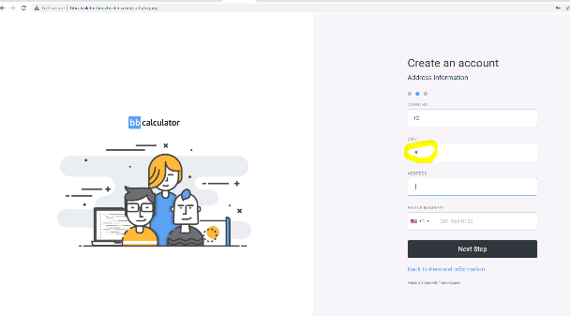**Notes:**  
* See the attached screenshots.

**Bug report 6**

**Bug ID:** abc006

**Bug Title:** Phone number line defects in Address Information part of Create an account.

**Reported By:** Ani Ghazaryan

**Reported On:** 06 May 2022

**Bug Summary:** Quantitative limit should be initially mentioned for each county phone numbers, so the program will complain when the length of the defined standard exceeds or is inferior to and it will be understandable.

**Bug URL:** [**http://bbcalculator.bugzbusters.com/auth/signup**](http://bbcalculator.bugzbusters.com/auth/signup)

**Environment:** Windows 10, Chrome

**Steps to Reproduce:**  
1) Navigate to [**http://bbcalculator.bugzbusters.com/login**](http://bbcalculator.bugzbusters.com/login)  
2) Click on the “[New? Register now](http://bbcalculator.bugzbusters.com/auth/signup)” button  
3) Write something in “FIRST NAME*” line

4) Write something in “LAST NAME*” line

5) Write date in “DATE OF BIRTH*” line

6) Click on the “Next Step”

7) Write something in “COUNTRY” line

8) Write something in “CITY” line

9) Write digits in “PHONE NUMBER*” line

**Expected Result:**

You should write a valid phone number for each county.

**Actual Result:**   
Defect in step 9 – There isn’t mentioned the standard quantity of numbers for phone number in each country.

**Severity:** Medium   
**Priority:** Medium

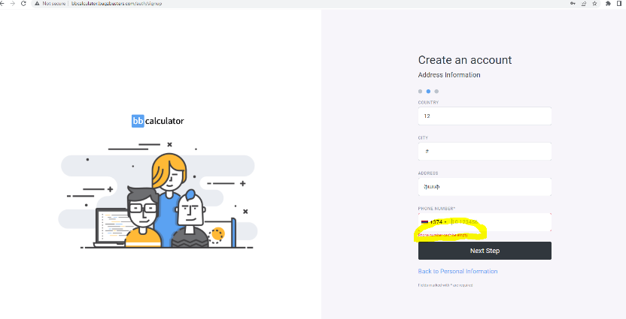**Notes:**  
* See the attached screenshots.

**Bug report 7**

**Bug ID:** abc007

**Bug Title:** E-mail line defects in Login Information part of Create an account.

**Reported By:** Ani Ghazaryan

**Reported On:** 06 May 2022

**Bug Summary:** There are certain standards for e-mail addresses that must be observed, but here for example you can write a digit + @mail.ru and it will be accepted as a valid mail.

**Bug URL:** [**http://bbcalculator.bugzbusters.com/auth/signup**](http://bbcalculator.bugzbusters.com/auth/signup)

**Environment:** Windows 10, Chrome

**Steps to Reproduce:**  
1) Navigate to [**http://bbcalculator.bugzbusters.com/login**](http://bbcalculator.bugzbusters.com/login)  
2) Click on the “[New? Register now](http://bbcalculator.bugzbusters.com/auth/signup)” button  
3) Write something in “FIRST NAME*” line

4) Write something in “LAST NAME*” line

5) Write date in “DATE OF BIRTH*” line

6) Click on the “Next Step”

7) Write something in “COUNTRY” line

8) Write something in “CITY” line

9) Write digits in “PHONE NUMBER*” line

10) Click on “Next Step”

11) Write a mail in “EMAIL” line

**Expected Result:**

You should write a valid e-mail address.

**Actual Result:**   
Defect in step 11 – The standards for e-mail address are not observed and you can write invalid e-mail address and it will be accepted.

**Severity:** Medium   
**Priority:** Medium

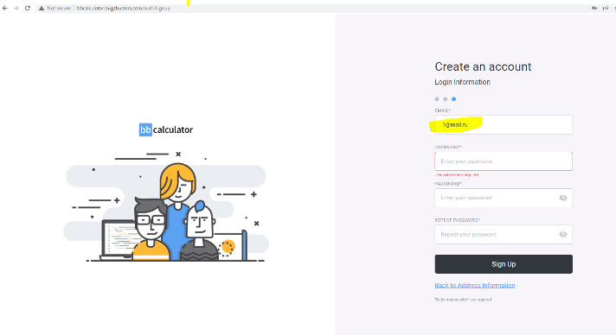**Notes:**  
* See the attached screenshots.

**Bug report 8**

**Bug ID:** abc008

**Bug Title:** Username line defects in Login Information part of Create an account.

**Reported By:** Ani Ghazaryan

**Reported On:** 06 May 2022

**Bug Summary:** There was written that Username should contain 3 - 32 Latin letters, digits and symbols (, ' -), but you can write for example, simply 3 Latin letters or digits and move forward**.**

**Bug URL:** [**http://bbcalculator.bugzbusters.com/auth/signup**](http://bbcalculator.bugzbusters.com/auth/signup)

**Environment:** Windows 10, Chrome

**Steps to Reproduce:**  
1) Navigate to [**http://bbcalculator.bugzbusters.com/login**](http://bbcalculator.bugzbusters.com/login)  
2) Click on the “[New? Register now](http://bbcalculator.bugzbusters.com/auth/signup)” button  
3) Write something in “FIRST NAME*” line

4) Write something in “LAST NAME*” line

5) Write date in “DATE OF BIRTH*” line

6) Click on the “Next Step”

7) Write something in “COUNTRY” line

8) Write something in “CITY” line

9) Write digits in “PHONE NUMBER*” line

10) Click on “Next Step”

11) Write a mail in “EMAIL” line

12) Write something in “USERNAME” line

**Expected Result:**

You should write Username that contains 3 - 32 Latin letters, digits and symbols (, ' -).

**Actual Result:**   
Defect in step 12 – You can write for example, simply 3 Latin letters or digits and move forward**.**

**Severity:** Medium   
**Priority:** Medium

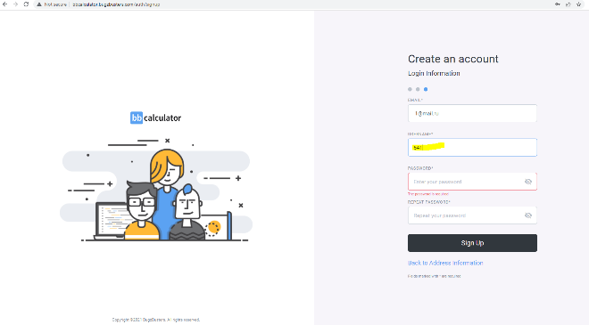**Notes:**  
* See the attached screenshots.

**Bug report 9**

**Bug ID:** abc009

**Bug Title:** Password and Repeat password lines defect in Login Information part of Create an account.

**Reported By:** Ani Ghazaryan

**Reported On:** 06 May 2022

**Bug Summary:** Both in Password and Repeat password lines you can write password starting with white space and have spaces in password and it will be considered as a character.

**Bug URL:** [**http://bbcalculator.bugzbusters.com/auth/signup**](http://bbcalculator.bugzbusters.com/auth/signup)

**Environment:** Windows 10, Chrome

**Steps to Reproduce:**  
1) Navigate to [**http://bbcalculator.bugzbusters.com/login**](http://bbcalculator.bugzbusters.com/login)  
2) Click on the “[New? Register now](http://bbcalculator.bugzbusters.com/auth/signup)” button  
3) Write something in “FIRST NAME*” line

4) Write something in “LAST NAME*” line

5) Write date in “DATE OF BIRTH*” line

6) Click on the “Next Step”

7) Write something in “COUNTRY” line

8) Write something in “CITY” line

9) Write digits in “PHONE NUMBER*” line

10) Click on “Next Step”

11) Write a mail in “EMAIL*” line

12) Write something in “USERNAME*” line

13) Write password in “PASSWORD*” line

14) Repeat password in “REPEAT PASSWORD *” line

**Expected Result:**

You should write a Password that must contain at least eight characters, both lowercase and uppercase letters, as well as at least one digit.

**Actual Result:**  
Defect in step 13 and 14 – You can write a Password starting with a white space and using spaces in it and they will be considered as characters and you can move forward**.**

**Severity:** Medium  
**Priority:** Medium

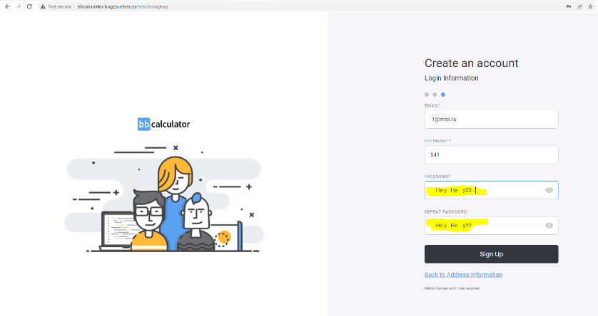**Notes:**  
* See the attached screenshots.

**Bug report 10**

**Bug ID:** abc010

**Bug Title:** Sign up button defects in Login Information part of Create an account.

**Reported By:** Ani Ghazaryan

**Reported On:** 06 May 2022

**Bug Summary:** After entering a valid e-mail address, when you click on the “Sign up” button, it says Check your mailbox, but you get nothing.

**Bug URL:** [**http://bbcalculator.bugzbusters.com/auth/signup**](http://bbcalculator.bugzbusters.com/auth/signup)

**Environment:** Windows 10, Chrome

**Steps to Reproduce:**  
1) Navigate to [**http://bbcalculator.bugzbusters.com/login**](http://bbcalculator.bugzbusters.com/login)  
2) Click on the “[New? Register now](http://bbcalculator.bugzbusters.com/auth/signup)” button  
3) Write something in “FIRST NAME*” line

4) Write something in “LAST NAME*” line

5) Write date in “DATE OF BIRTH*” line

6) Click on the “Next Step” button

7) Write something in “COUNTRY” line

8) Write something in “CITY” line

9) Write digits in “PHONE NUMBER*” line

10) Click on “Next Step” button

11) Write a mail in “EMAIL*” line

12) Write something in “USERNAME*” line

13) Write password in “PASSWORD*” line

14) Repeat password in “REPEAT PASSWORD *” line

15) Click on “Sign up” button

**Expected Result:**

After entering a valid e-mail address, when you click on “Sign up” button in your mailbox you must receive a link to activate your account.

**Actual Result:**   
Defect in step 15 – After entering a valid e-mail address, when you click on “Sign up” button in your mailbox you don’t receive anything.

**Severity:** High  
**Priority:** High

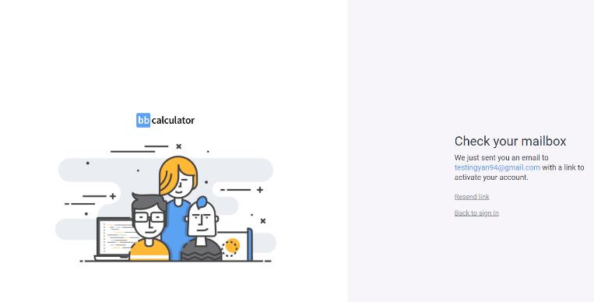**Notes:**  
* See the attached screenshots.

**Bug report 11**

**Bug ID:** abc011

**Bug Title:** “Resend link” button defects while creating an account.

**Reported By:** Ani Ghazaryan

**Reported On:** 06 May 2022

**Bug Summary:** After clicking the “Set Up” button, when you click the "Resend Link" button, you will not get anything in your mailbox again.

**Bug URL:** [**http://bbcalculator.bugzbusters.com/auth/signup**](http://bbcalculator.bugzbusters.com/auth/signup)

**Environment:** Windows 10, Chrome

**Steps to Reproduce:**  
1) Navigate to [**http://bbcalculator.bugzbusters.com/login**](http://bbcalculator.bugzbusters.com/login)  
2) Click on the “[New? Register now](http://bbcalculator.bugzbusters.com/auth/signup)” button  
3) Write something in “FIRST NAME*” line

4) Write something in “LAST NAME*” line

5) Write date in “DATE OF BIRTH*” line

6) Click on the “Next Step” button

7) Write something in “COUNTRY” line

8) Write something in “CITY” line

9) Write digits in “PHONE NUMBER*” line

10) Click on “Next Step” button

11) Write a mail in “EMAIL*” line

12) Write something in “USERNAME*” line

13) Write password in “PASSWORD*” line

14) Repeat password in “REPEAT PASSWORD *” line

15) Click on “Sign up” button

16) Click on “Resend link” button

**Expected Result:**

After clicking the "Resend Link" button, in your mailbox you must receive a link to activate your account.

**Actual Result:**   
Defect in step 16 – After clicking the "Resend Link" button, in your mailbox you don’t receive anything.

**Severity:** High  
**Priority:** High

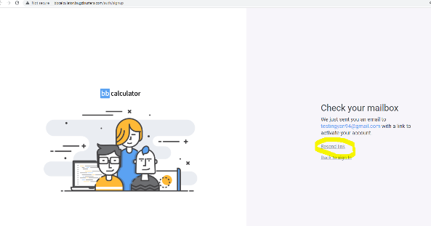**Notes:**  
* See the attached screenshots.

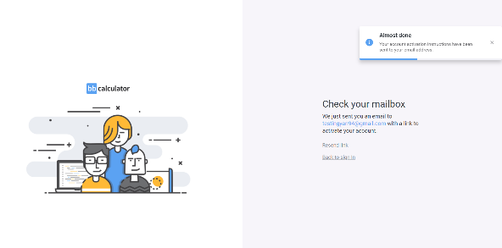

**Bug report 12**

**Bug ID:** abc012

**Bug Title:** After clicking “[Forgot your password?” button](http://bbcalculator.bugzbusters.com/auth/reset-password) in Reset Password field “EMAIL ADDRESS” line defects.

**Reported By:** Ani Ghazaryan

**Reported On:** 06 May 2022

**Bug Summary:** When you click on “[Back to sign In](http://bbcalculator.bugzbusters.com/auth/login)” button and then click on the “[Forgot your password?”](http://bbcalculator.bugzbusters.com/auth/reset-password), in opened Reset Password field in “EMAIL ADDRESS” line you can write what you want and the program will not complain, the e-mail address standards are not observed․

**Bug URL:** [**http://bbcalculator.bugzbusters.com/auth/reset-password**](http://bbcalculator.bugzbusters.com/auth/reset-password)

**Environment:** Windows 10, Chrome

**Steps to Reproduce:**  
1) Navigate to [**http://bbcalculator.bugzbusters.com/login**](http://bbcalculator.bugzbusters.com/login)  
2) Click on the “[New? Register now](http://bbcalculator.bugzbusters.com/auth/signup)” button  
3) Write something in “FIRST NAME*” line

4) Write something in “LAST NAME*” line

5) Write date in “DATE OF BIRTH*” line

6) Click on the “Next Step” button

7) Write something in “COUNTRY” line

8) Write something in “CITY” line

9) Write digits in “PHONE NUMBER*” line

10) Click on “Next Step” button

11) Write a mail in “EMAIL*” line

12) Write something in “USERNAME*” line

13) Write password in “PASSWORD*” line

14) Repeat password in “REPEAT PASSWORD *” line

15) Click on “Sign up” button

16) Click on “Resend link” button

17) Click on “[Back to sign In](http://bbcalculator.bugzbusters.com/auth/login)” button

18) Click on “[Forgot your password?](http://bbcalculator.bugzbusters.com/auth/reset-password)”

19) Write something in “EMAIL ADDRESS” line

**Expected Result:**

After clicking the “[Forgot your password?”](http://bbcalculator.bugzbusters.com/auth/reset-password) button, in opened Reset Password field particularly in “EMAIL ADDRESS” line you must write a valid e-mail address.

**Actual Result:**  
Defect in step 19 – After clicking the “[Forgot your password?”](http://bbcalculator.bugzbusters.com/auth/reset-password) button, in opened Reset Password field particularly in “EMAIL ADDRESS” line you can write invalid e-mail address and the program will not complain.

**Severity:** High  
**Priority:** High

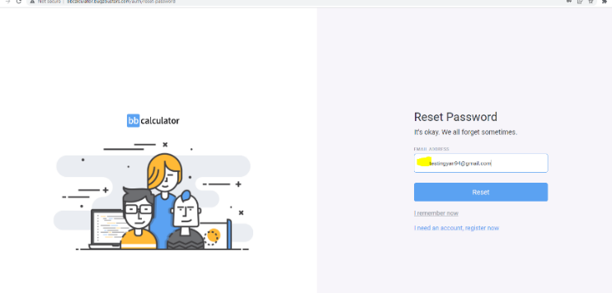**Notes:**  
* See the attached screenshots.

**Bug report 13**

**Bug ID:** abc013

**Bug Title:** After clicking “[Forgot your password?” button](http://bbcalculator.bugzbusters.com/auth/reset-password) in Reset Password field “Reset” button defect.

**Reported By:** Ani Ghazaryan

**Reported On:** 06 May 2022

**Bug Summary:** In Reset Password field, after writing an valid user e-mail address, when you click on “Reset” button, you must receive a link in your mailbox, but you got nothing.

**Bug URL:** [**http://bbcalculator.bugzbusters.com/auth/reset-password**](http://bbcalculator.bugzbusters.com/auth/reset-password)

**Environment:** Windows 10, Chrome

**Steps to Reproduce:**  
1) Navigate to [**http://bbcalculator.bugzbusters.com/login**](http://bbcalculator.bugzbusters.com/login)  
2) Click on the “[New? Register now](http://bbcalculator.bugzbusters.com/auth/signup)” button  
3) Write something in “FIRST NAME*” line

4) Write something in “LAST NAME*” line

5) Write date in “DATE OF BIRTH*” line

6) Click on the “Next Step” button

7) Write something in “COUNTRY” line

8) Write something in “CITY” line

9) Write digits in “PHONE NUMBER*” line

10) Click on “Next Step” button

11) Write a mail in “EMAIL*” line

12) Write something in “USERNAME*” line

13) Write password in “PASSWORD*” line

14) Repeat password in “REPEAT PASSWORD *” line

15) Click on “Sign up” button

16) Click on “Resend link” button

17) Click on “[Back to sign In](http://bbcalculator.bugzbusters.com/auth/login)” button

18) Click on “[Forgot your password?](http://bbcalculator.bugzbusters.com/auth/reset-password)”

19) Write an valid user email in “EMAIL ADDRESS” line

20) Click on “Reset” button

**Expected Result:**

After clicking the “[Forgot your password?”](http://bbcalculator.bugzbusters.com/auth/reset-password) button, in opened Reset Password field, after writing an valid user e-mail address, when you click on “Reset” button, you must receive a link in your mailbox.

**Actual Result:**  
Defect in step 19 – After clicking the “[Forgot your password?”](http://bbcalculator.bugzbusters.com/auth/reset-password) button, in opened Reset Password field, after writing an valid user e-mail address, when you click on “Reset” button you got nothing in your mailbox.

**Severity:** Medium  
**Priority:** Medium

**Notes:**   
* See the attached screenshots.

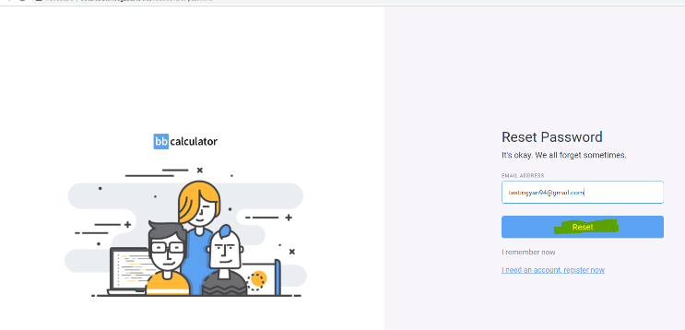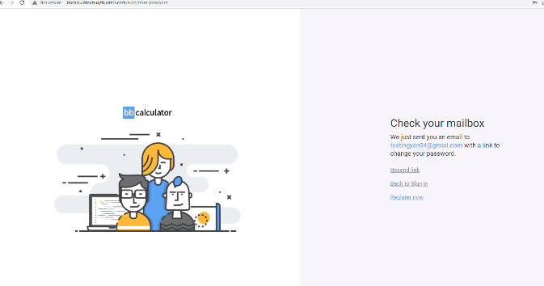

**Bug report 14**

**Bug ID:** abc014

**Bug Title:** In Reset Password field after clicking “Reset” button, in opened “Check your mailbox” field “Resend link” button defect.

**Reported By:** Ani Ghazaryan

**Reported On:** 06 May 2022

**Bug Summary:** In Reset Password field, after writing an valid user e-mail address, when you click on “Reset” button, in opened “Check your mailbox” field “Resend link” button is empty and don’t work.

**Bug URL:** [**http://bbcalculator.bugzbusters.com/auth/reset-password**](http://bbcalculator.bugzbusters.com/auth/reset-password)

**Environment:** Windows 10, Chrome

**Steps to Reproduce:**  
1) Navigate to [**http://bbcalculator.bugzbusters.com/login**](http://bbcalculator.bugzbusters.com/login)  
2) Click on the “[New? Register now](http://bbcalculator.bugzbusters.com/auth/signup)” button  
3) Write something in “FIRST NAME*” line

4) Write something in “LAST NAME*” line

5) Write date in “DATE OF BIRTH*” line

6) Click on the “Next Step” button

7) Write something in “COUNTRY” line

8) Write something in “CITY” line

9) Write digits in “PHONE NUMBER*” line

10) Click on “Next Step” button

11) Write a mail in “EMAIL*” line

12) Write something in “USERNAME*” line

13) Write password in “PASSWORD*” line

14) Repeat password in “REPEAT PASSWORD *” line

15) Click on “Sign up” button

16) Click on “Resend link” button

17) Click on “[Back to sign In](http://bbcalculator.bugzbusters.com/auth/login)” button

18) Click on “[Forgot your password?](http://bbcalculator.bugzbusters.com/auth/reset-password)”

19) Write an valid user email in “EMAIL ADDRESS” line

20) Click on “Reset” button

21) Click on “Resend link “

**Expected Result:**

After clicking the “[Forgot your password?”](http://bbcalculator.bugzbusters.com/auth/reset-password) button, in opened Reset Password field, after writing an valid user e-mail address, when you click on “Reset” button, in opened “Check your mailbox” field “Resend link” button must be clickable and work.

**Actual Result:**  
Defect in step 19 – After clicking the “[Forgot your password?”](http://bbcalculator.bugzbusters.com/auth/reset-password) button, in opened Reset Password field, after writing an valid user e-mail address, when you click on “Reset” button in opened “Check your mailbox” field “Resend link” button is empty and don’t work.

**Severity:** High  
**Priority:** High

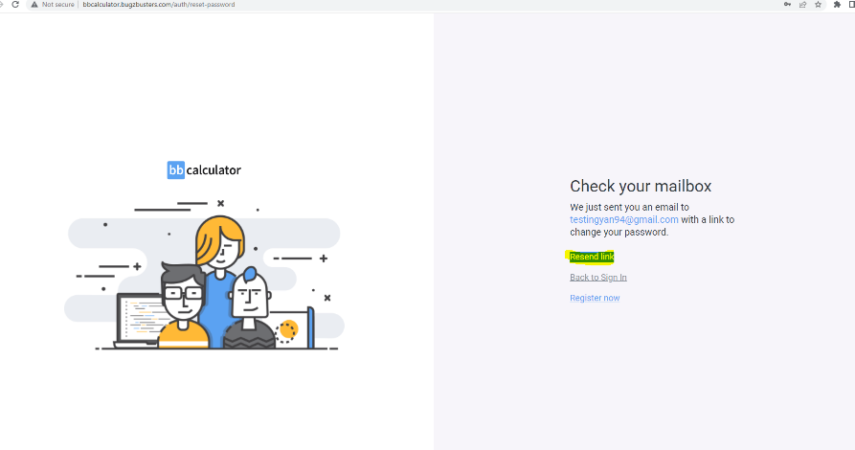**Notes:**   
* See the attached screenshots.